October 2026

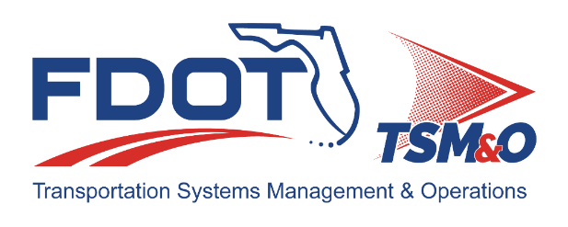
Florida ITS Architecture Support and Maintenance Project
SITSA Update Report
(ARC-IT Version 9.4)

Document Version Control
Author / Action | Submittal Date | Version No.
Faranak Ashkiani / Draft Document Development | October 5, 2026 | A94-10/2026
David Binkley / QA/QC Review | October 5, 2026 | A94-10/2026

Table of Contents
1.0 Introduction 4
2.0 Description of Changes 4

List of Tables
Table 1. Architecture Updates 4
Table 2. Architecture Maintenance Log (SITSA) 7

Introduction
This Architecture Update Report for the Florida Statewide Intelligent Transportation Systems (ITS) Architecture (SITSA) identifies the revisions incorporated into the architecture. Revisions made to the SITSA are documented in this report to support Stakeholder input received through Architecture Change Requests as part of the Florida ITS Architecture Support and Maintenance Project.
The Florida ITS Architecture Support and Maintenance Project included the initial major update of the Statewide Regional ITS Architecture and seven Regional ITS Architectures. Following the major update phase, periodic updates are executed to maintain the architecture content. The FDOT Architecture Team coordinates with the FDOT Project Manager or designee and each applicable District Transportation Systems Management and Operations (TSM&O) Program Engineer or designee for the RITSAs.

Description of Changes
This update incorporates one maintenance log item. Table 1 provides descriptions for each change request that was implemented in this architecture update. A log reference number is provided for each change to relate it to the Architecture Maintenance Log that is provided in Appendix A. Each architecture change that is received is added to the maintenance log for tracking and disposition.
Information about stakeholders, elements, and services is provided to summarize the changes. Some architecture components such as interfaces, roles and responsibilities, functional requirements and standards are numerous and can be reviewed on the architecture website or in the Regional Architecture Development for Intelligent Transportation (RAD-IT) software tool to explore the details of each project.
Table 1. Architecture Updates
Change | Log Ref # | Actions Taken / Changes Implemented
Weather Data Collection service package added | 220 | - Added WX01: Weather Data Collection service package to Florida Data Exchange Platform for Operational Technology (DEPOT) project and regional architecture  - Assigned Elements:  - FDOT District TMCs using SunGuide  - Florida DEPOT  - FTE Operations Center (Pompano)  - FTE Operations Center (Turkey Lake)  - Added User Needs.  - Added Roles and Responsibilities.  - Added Functional Requirements.  - Added Interfaces.  - Added Communications.
The Information flow diagrams need to be reviewed | 220 | The information flows were reviewed and revised to reflect stakeholder feedback:  - Some of information flows were removed  - The status of several of the information flows were changed  - Some of the flow directions were Reversed  - Some information flows were added

Appendix A: Architecture Maintenance Log (SITSA)
The maintenance log in Table 2 provides the SITSA maintenance items considerations for the update.
Table 2. Architecture Maintenance Log (SITSA)
# | Date | Source | Contact | Change | Disposition | Recommend Maintenance | Incorporated
220 | 7/30/2026 | Change Request | Joseph Casper/ FDOT CO | DEPOT Architecture Updates - see spreadsheet attached to change request for specifics. | Update flows, status values, and service packages as needed. | Yes | Yes

